User Manual

SCN UPLC Batch Helper

Version 1.0.0

February 09, 2023

# Tool Description and Overview

The “scn_uplc_batch_helper_v1_0_0.py” tool is a computer program written in the Python3 programming language that enables QC laboratory personnel to efficiently and reliably prepare the paperwork required to perform UPLC analysis in a GMP/GLP environment. The tool uses a simple and intuitive graphical user interface (GUI), a newly created UPLC specification database, and performs logic and mathematical calculations to populate the UPLC forms correctly and completely. The forms are completed, and any unused form sections are automatically crossed out, initialed, and dated (full GMP compliance). The used sections contain important information relevant to each analysis and are populated with referenced or calculated values to reduce or eliminate transcription or calculation errors. The appropriate checkboxes are marked based on logic and all forms are legible reducing interpretation errors during review or audit procedures. The font size is dynamically adjusted to ensure that all information is legible and no overlapping information occurs on the output forms.

**Estimated time savings:** 1-3 hours/analyst/day

# Quick Start Guide

Open the Terminal by typing ‘cmd’ followed by <Enter> in the Windows search bar located at the bottom left side of the computer screen.

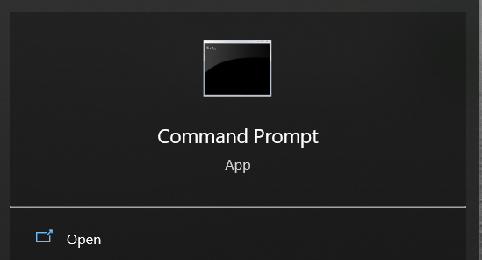

In the prompt, type the following command (without the quotation marks) to navigate to the :

*“cd Desktop\SCN_UPLC_Batch_Helper && python3 scn_uplc_batch_helper_v1_0_0.py”*

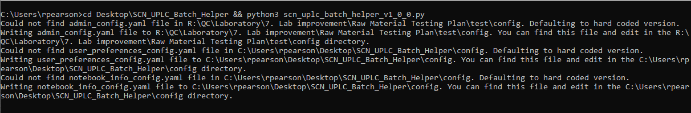

If this is the first time running the program on a computer, notices will appear in the terminal to tell the user that configuration files have been made and where they can be located for editing, if required. The graphical user interface should now appear on screen.

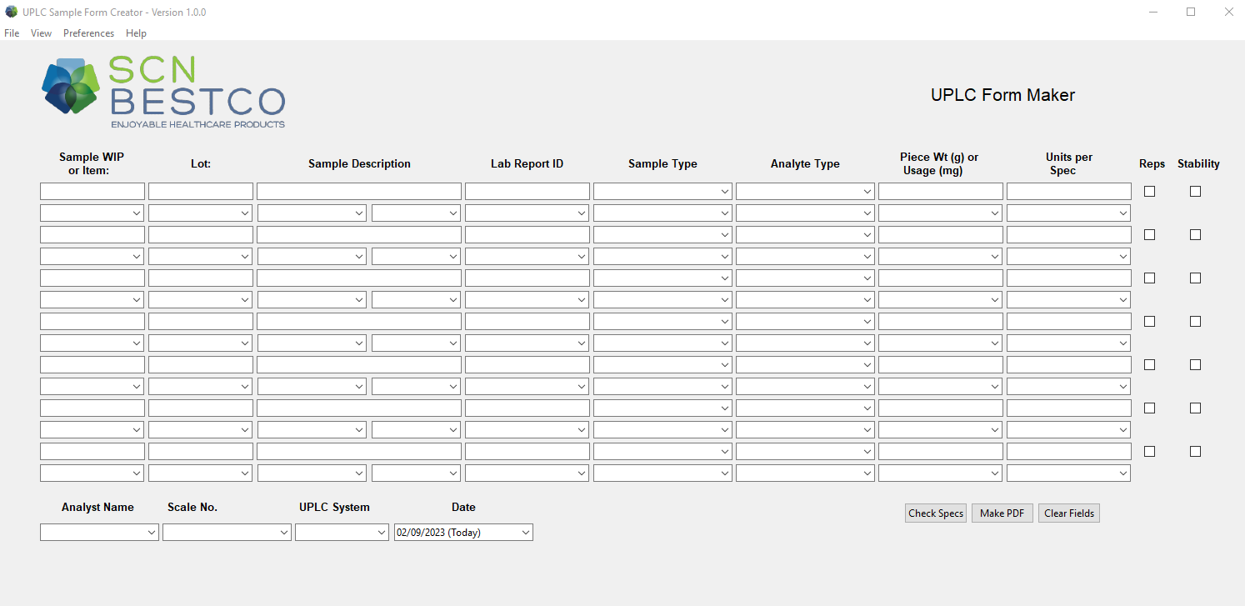

The user has the option to set up the Analyst Name, Scale No., and UPLC System fields in the “user_preferences_config.yaml” file located in the ./config directory. This file can be opened using any text editor. A good choice for this is notepad.

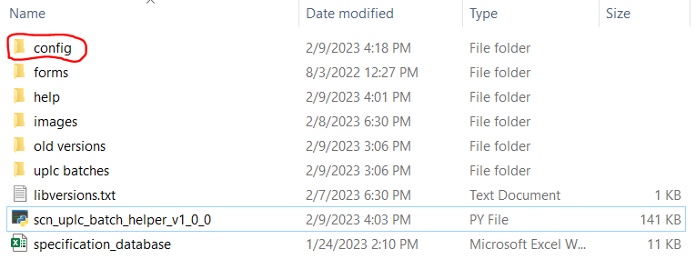

Gather your samples and enter the WIP/Item number for the samples in the first column (skip the even rows).

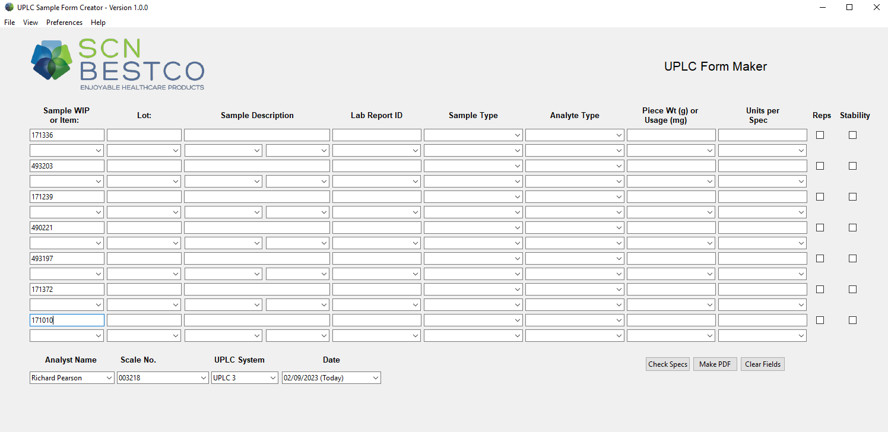

Now press the “Check Specs” button located at the bottom right hand of the GUI. If the WIP or Item number is found in the password protected database, the Sample Description, Sample Type, Piece Weight/Usage Rate, and Units per Spec will automatically populate. If the specification is not found, you will need to manually enter this information.

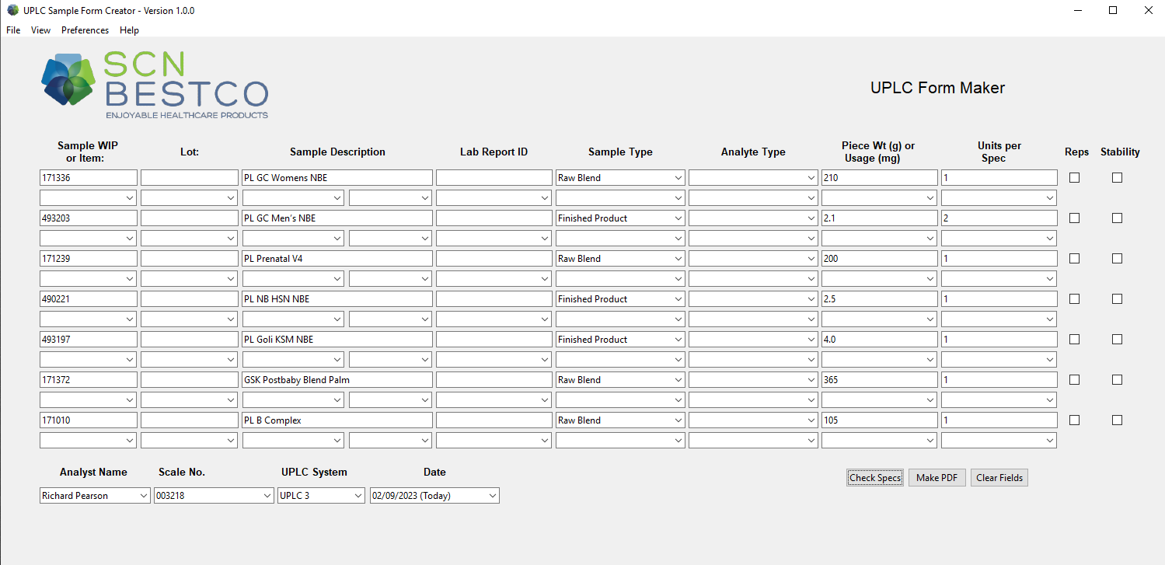

Now it is time to fill in the Lot number, Lab Report ID, Analyte Type, and the Tests you wish to perform (even rows).

Notes:

* The program will automatically capitalize lot numbers so feel free to leave the lot information as lower case.
* You can easily navigate to adjacent fields by pressing the arrow keys.
* By pressing <ctrl> + d you will copy the cell you are focused on to the rest of the cells in that column.
* The fat-soluble test analytes are in the first 4 columns in the even rows.
* The water-soluble test analytes are in the last 5 columns in the even rows.
* If a sample is a stability sample check the box on the right and the specification printed will be the stability specification.
* If the sample required a triplicate retest, check the box in the Reps column.

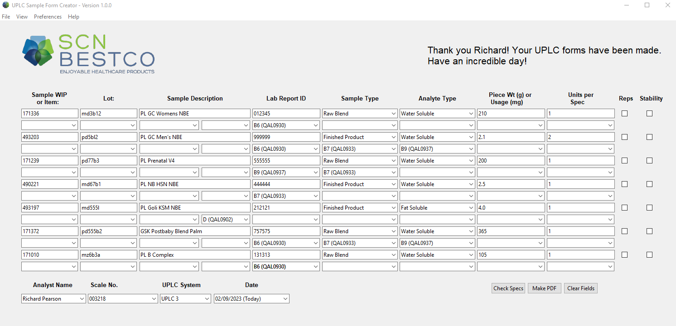

Now press the “Make PDF” button to generate the PDF sample packs.

## Example Output

## 

